DAY-1 P.SRINIVASA REDDY

ITA0441RPRORMMING

1. PRINTTHEVERSION

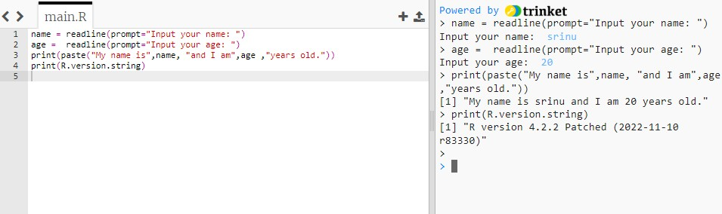

1. OBJECTINMEMORY

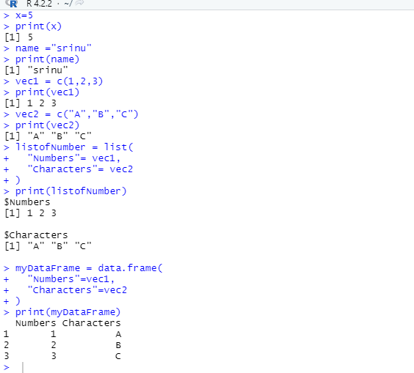

1. CREATEASEQUENCE

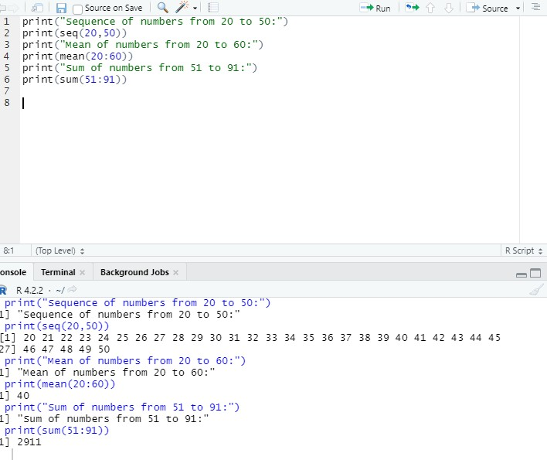

1. RANDOMINTEGERVALVES

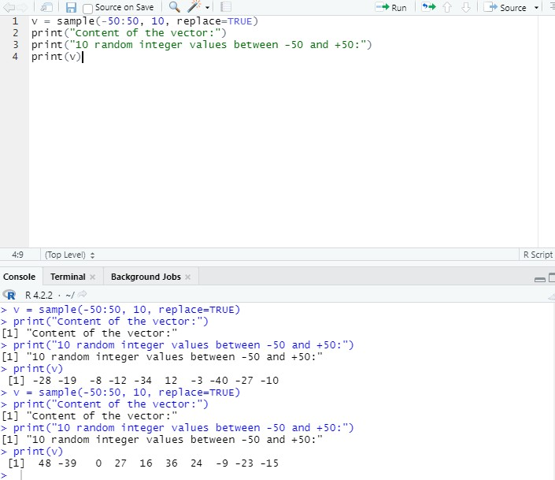

1. FIBONACCINUMBERS

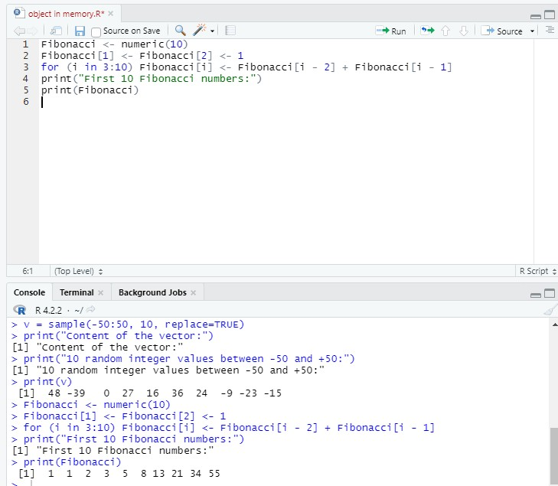

1. primenumbers

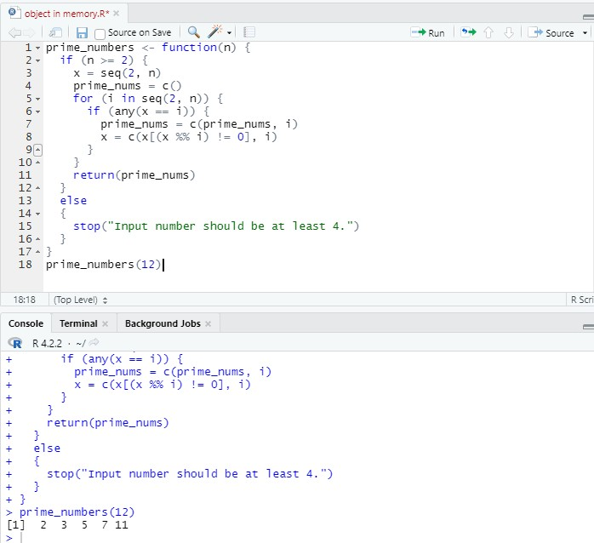

1. "fizzfor muliplesofmuliples

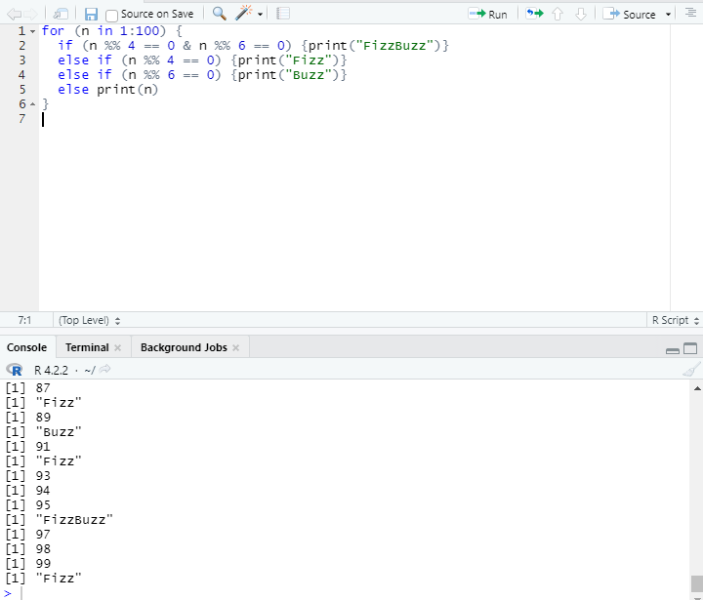

1. .RPROGAMTOPRINTTHEFRISTENGLISH

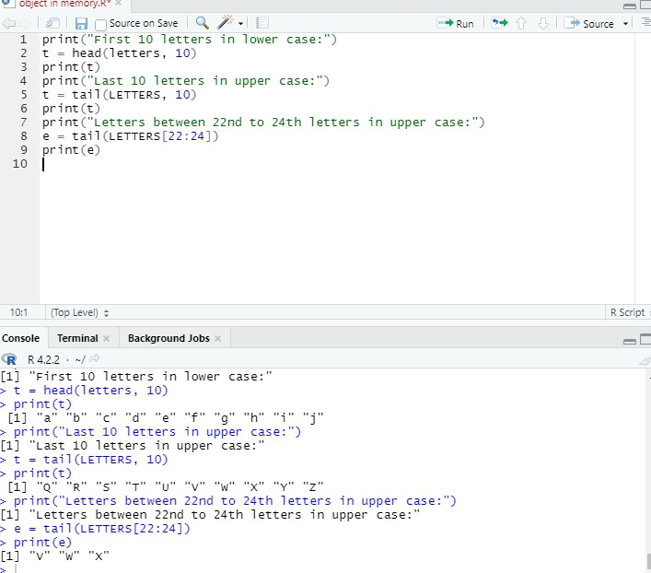

1. RPROGRAMTOFINDTHEFACTORS

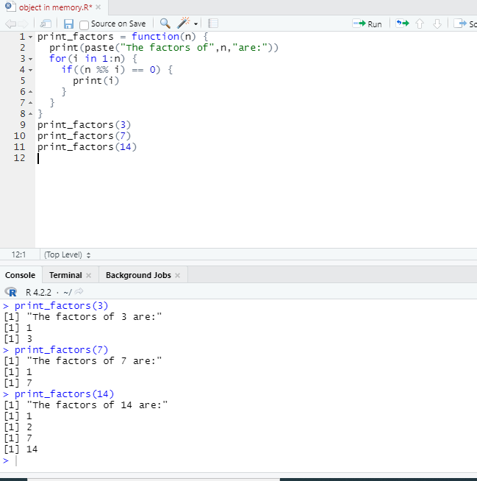

10.RPROGAMFORMAXIMUMANDMINIMUM

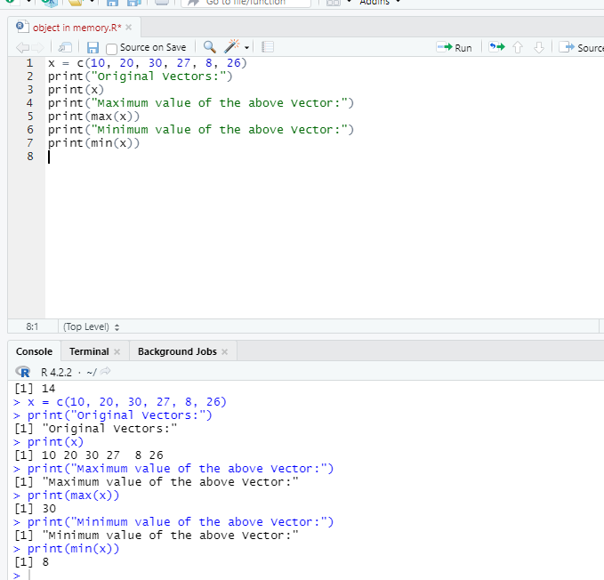

11WRITEARPROGRAMUNIQUEELEMENTS

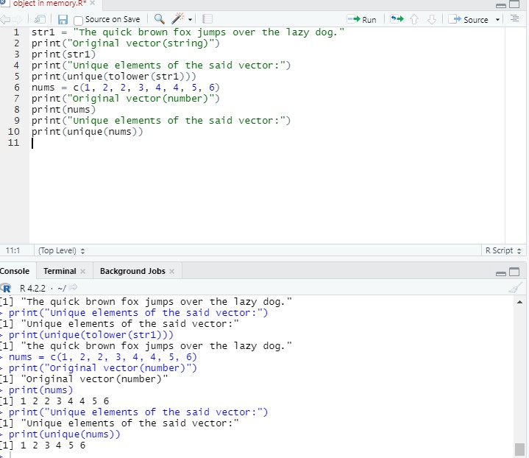

12.WRITEARPROGAMCREATETHREEVECTORS

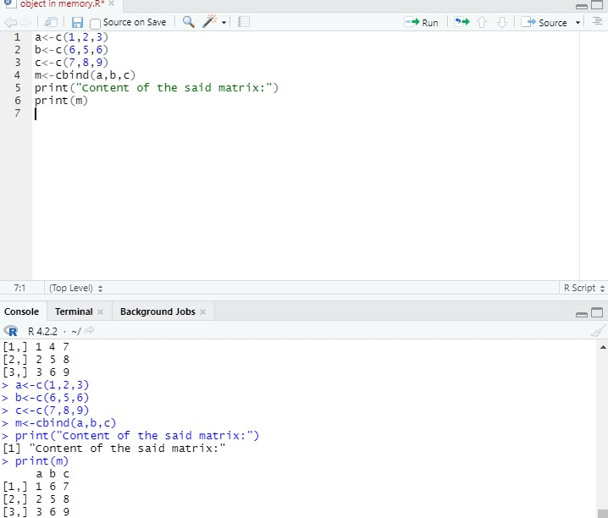

13.RPROGRAMNORMALDISTRIBUTION

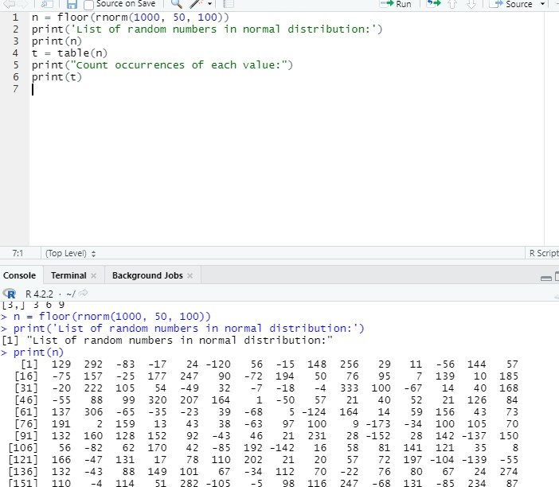

15.RPROGAMVECTORSNUMERICDATA

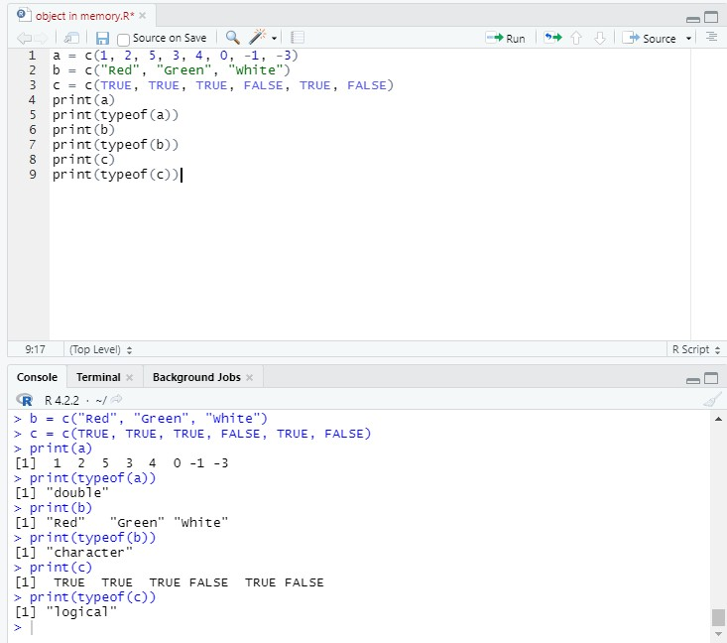

16.WRITEARPROGAMTOCREATE5\*4MATRIXAND3\*3MATRIX

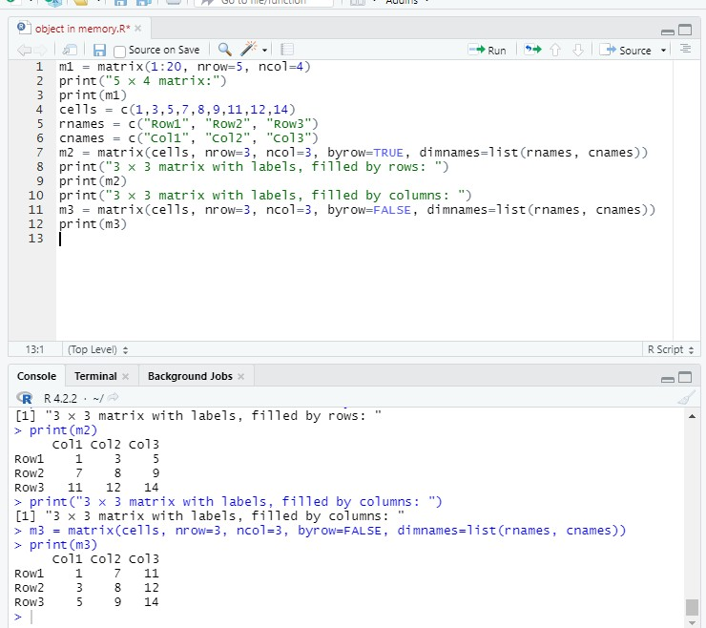

17WRITEARPROGRMCREATEANARRAY

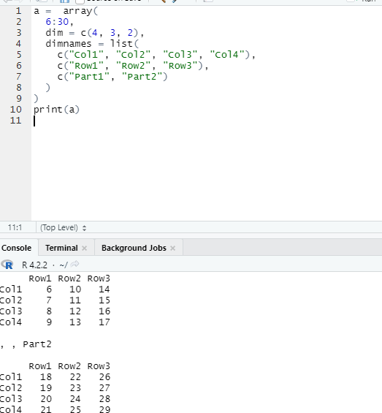

1. Writea Rprogramtocreateanarraywiththreecolumns

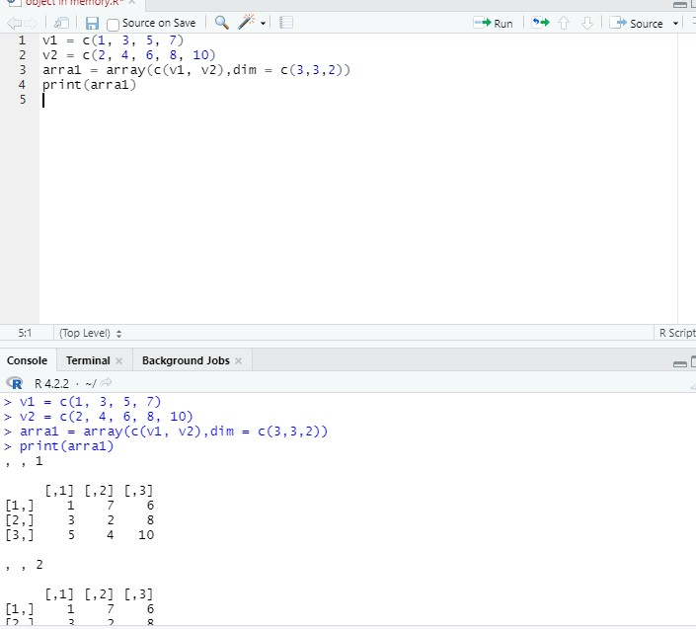

1. Write a Rprogramtocreatea listofelements usingvectors,matrices

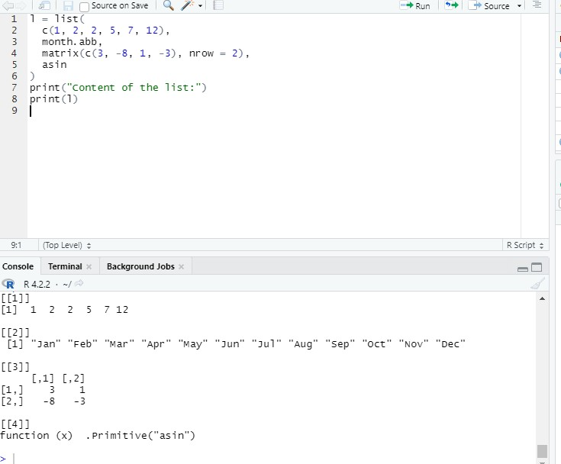

1. Write a Rprogramtodrawanemptyplotandanemptyplot specifytheaxes

